DRONNINGENS GATE 16 | 0152 OSLO | NORGE | WWW.INDIERECORDINGS.NO
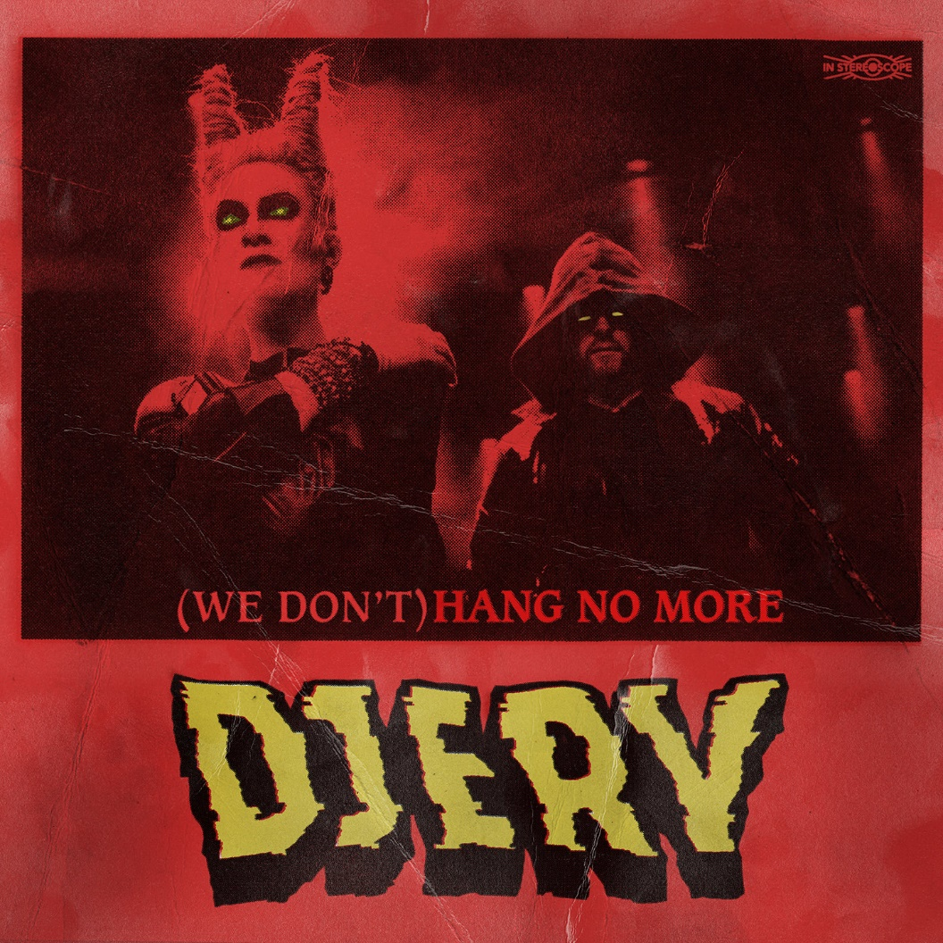
DJERV – “(We Don’t) Hang No More”
OUT SEPTEMBER 22nd
Following up on their successful comeback-single “Throne”, Djerv are ready to launch yet another hard-rock banger! Musically, “(We Don’t) Hang No More” sees the band continue their rock-focused path, while the lyrics are about ending relationships. Most of us have been there; be it your boyfriend, friend, colleague, or other relation. Certain people are just not worth the time and energy to hang out with anymore.

After a six-year-long hibernation, Djerv are fully recharged. The come-back single “Throne” was released just before summer, and now the second single “(We Don`t) Hang No More” is ready for the audience. Djerv continue in the sound of which they became known, and at the same time going towards a more defined rock-sound. “It`s been really fun doing these tracks, just trying out something a bit different, something a bit more up-tempo and simpler. Not over-thinking it too much.” Erlend (drums) states.

Lyrically, the song is about ending relationships Agnete says; “As much as it hurts, some relationships just have to end. When you find yourselves disappointed time and time again, when you expected more but finally realize there is nothing more there… well, it hurts. But instead of breaking down you just have to deal with it and acknowledge the truth; We don’t hang no more.”

Despite the Covid-19 pandemic, Djerv are planning to do some few selected live shows this fall following up the release of their two new tracks: “Playing live is the biggest reward of being in a band, it makes all the hassle worth it” Erlend says. “We are fortunate that there is still an option to do some live shows and we intend to make the most of them. We`ll bring a bigger production than ever and show it to fewer people than ever. So this will be an exclusive time to see us play”, he smiles.

Judging by Metalhammer UK`s experience of Djerv`s last London show something good is in store for those who show up: “… when a band can unleash the kind of turbo-charged thrust that would peel a layer off Kvelertak fans, and when it`s embodied by both a voice and physical presence as unique and fearless as Agnete`s, you`re blasted into the realms of revelation from the off.” Jonathan Selzer, Metalhammer UK

“(We Don’t) Hang No More” will be out via Indie Recordings on September 22! The two come-back singles will also be available on 7” coloured vinyl (red and yellow)!
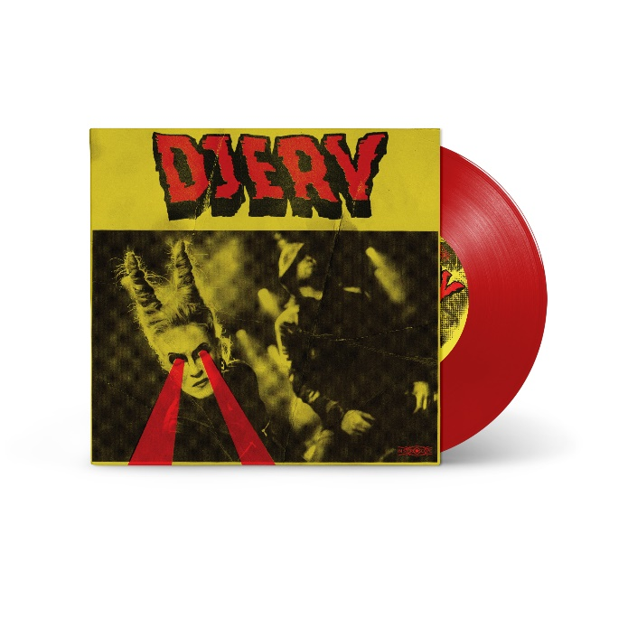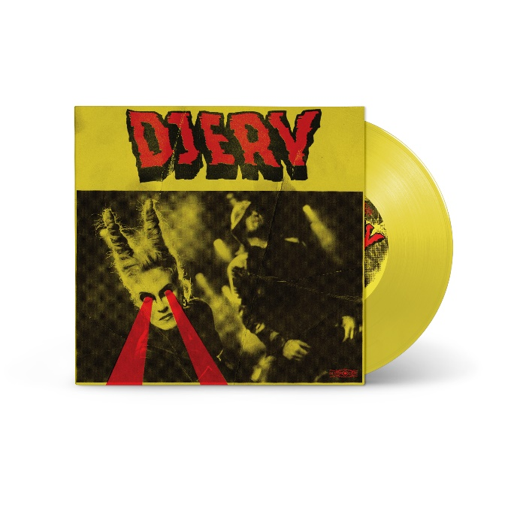

Background:
Djerv entered the international rock and metal-scene in 2011 with a debut record that still impresses in 2020. Engineered by Daniel Bergstrand (Meshuggah, In Flames) and mixed by Matt Hyde (Deftones, No Doubt) the album received critical acclaim with 9/10 in Sweden Rock Magazine, and Rock Tribune. The metal bible Metal Hammer UK gave it a solid 8/10 and said:
“Agnete Kjølsrud’s the star of the show, her vocals could take paint off your dad’s car!”
Terrorizer Magazine followed suit and said:
“Djerv are onto something big with their clever combination of hard rock and black metal… A talented band that are only just getting started”
And they were right. After only two days in sale, the debut album crashed into the official Norwegian sales charts at an impressive #8. They were also the highest newcomer and #3 on Norwegian Artist Charts. Spearheaded by their singles “Headstone” and “Madman” their success was immediate. During the next years, the band toured heavily, amongst others with Ministry, and established themselves in the European rock and metal scene. Djerv also performed at festivals like Hellfest, Wacken, Eurosonic, Rock Hartz and Inferno to name a few. Despite the heavy touring the Djerv-universe spread outside the band itself as Agnete found time to contribute with clean-vocals on Dimmu Borgir`s most-streamed song on Spotify, «Gateways», and she did the track «Get Jinxed» for «League Of Legends», one of the biggest online games in the world. This track went on to be a viral hit currently having reached almost 95.000.000 plays on YouTube. After few appearances at summer festivals in 2019, Djerv are now ready to hit hard the European stages in 2020!

Djerv Live:
Nov/Dec 20 – Norway tour TBA
11.12.20 – Eindhoven Metal Meeting (NL)
01.04.21 – Inferno Festival (NO)
25.09.21 – Nordic Metal Meeting (FI)
Jan/Feb 21 – Headliner tour Nordics TBA

Djerv is:
Agnete Kjølsrud
Erlend Gjerde
(We Don`t) Hang No More Credits:
Music by: Agnete Kjølsrud, Erlend Gjerde, Stamos Koliousis
Lyrics by: Agnete Kjølsrud, Erlend Gjerde
Recorded & Mixed by Stamos Koliousis
Produced by Djerv & Stamos Koliousis
Mastered by Nick Terry
P-Line: Indie Recordings AS under exclusive license from Djerv Music
C- Line: Indie Recordings AS

WEBSITE | FACEBOOK | INSTAGRAM | SPOTIFY | YOUTUBE

