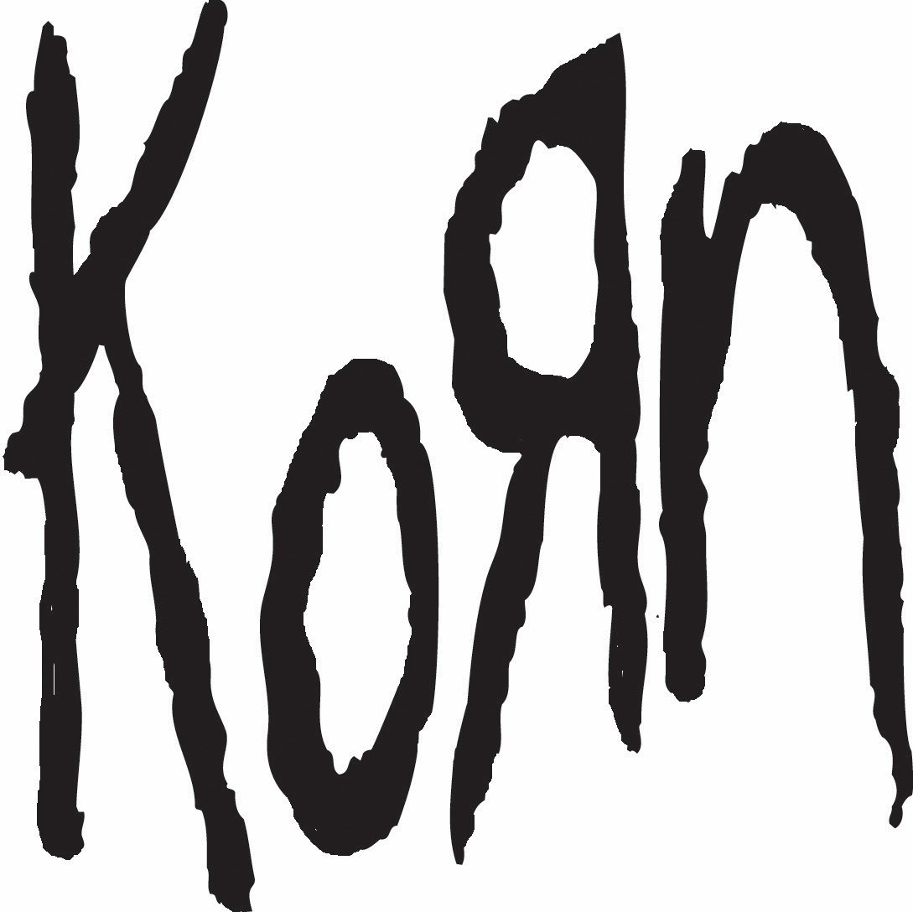

The Serenity of Suffering Biography

Jonathan Davis (vocals) James “Munky” Shaffer (guitar)
Brian “Head” Welch (guitar) Reginald “Fieldy” Arvizu (bass) Ray Luzier (drums)

“The Serenity of Suffering defines my life and the record,” says Jonathan Davis of the title of KORN’s 12th studio album, pointing out the balance of how his dark moments have often made him feel most at ease. “That title sums up every song on the album. I’m always put in fucked up situations where I’m dying inside and I just take it. Why do I hurt myself constantly? Why do I put myself through this hell? And I came up with the conclusion that suffering is the only way I feel safe and serene. I must like it. It must make me feel at home when I’m hurting. If you’ve been there, you understand. Being excruciatingly happy or any other emotion for me is kind of foreign and weird. When I explain it to
people they think I’m crazy and they don’t understand, but core fans understand.”

Since forming in 1993 in Huntington Beach, CA the iconic hard rock band KORN have sold nearly 40 million albums, toured the world dozens of times, and set records in the process that will likely never be surpassed. Vocalist Jonathan Davis, guitarists James “Munky” Shaffer and Brian “Head” Welch, and Reginald “Fieldy” Arvizu on bass ushered in the new wave of metal music in the ’90s with their self-titled debut in 1994 and 1996’s Life is Peachy, but have ridden that wave to even greater success and higher artistic water marks. The band have battled personal demons and addictions but have found their way through to the other side. And now, highlighted by a return to a dual-guitar dynamic and some of Davis’s most inspired moments of self-reflection and expression, the new album The Serenity of Suffering finds KORN harnessing all the anger, power, and trademark balance of darkness and light that made their name all those years ago.

In June of 2015, the band decided to make the follow-up to 2013’s The Paradigm Shift, which had signaled the return of Head after leaving KORN for several years for substance recovery. Aiming to make something different, the band didn’t want to repeat themselves or lean too much on the sound of their old material. Head, Munky and Ray began writing in a Hollywood studio before hiring producer Nick Raskulinecz (Foo Fighters, Deftones, Ghost) to help with the album. The band eventually traveled to his Rock Falcon Studios in Franklin, TN, and at the producer’s suggestion, the two guitarists began writing and recording simultaneously in the same room, facing each other while tracking songs.

“It was Nick’s idea,” Munky says. “We’d only done it for demos, so we decided to try it. We ended up having such a great live feeling and energy and it was making us play better. So that was the green light to keep going. We did 99-percent of the guitar writing together. It really challenged each of us to play the best we could.”

“Me and Munky work so well together,” Head says. “What I lack he takes care of, and vice-versa. I’m more of the melody guy, the big chords and the hooky melodies, and Munky is more trippy, the master of the Mr. Bungle-type of weird stuff that makes KORN sound unique. It fluctuates, but it happened organically. Our personalities come through our instruments.”

Raskulinecz flew to Bakersfield with the initial batch of tracks to work on vocals with Davis. As a singer who prefers to have music completed before beginning his singing parts, and always brutally honest, Davis tracked a handful of the songs, but others failed to capture his interest. As Davis explains, “I was in an emotional rut…I wasn’t inspired, I wasn’t thinking, I wasn’t anything.” Taking it in stride, Munky says, “If everyone’s not into it, you have to adjust and refocus.”

Continuing to push the pair of songwriters, Raskulinecz encouraged them to pen more and more songs, reminding the guitarists of the work ethic of their early days when they would lock themselves in a room day and night to work on their craft. Taking contributions from bassist Fieldy, who Munky hails for his producer-like ear and perfect suggestions, and drummer Luzier, who Munky calls “one of the best drummers on the planet,” the duo came up with a lengthy pile to send back to Davis, who began to put his own work in, and as he pushed himself to power through, he started to come through the darkness.

This time back in Bakersfield, Davis finished his vocals in a week and a half. He conquered his demons and delivered some of the finest performances of his career. “I realized Munky and Head really brought it with the performances and the writing,” Davis says. “The arrangements are a little different, and there are other cool things that are different this time so that’s what I keep going off of. And I hate sounding arrogant but I can sing; I’ve been doing it for a long time. I had faith in my brothers and everyone around me that this was good. I’ve built my career around being blatantly honest. And I’m being blatantly honest here.”

“I think that balance is something that we naturally feel,” Munky says. “It’s like looking at a painting. When you back up you can see what you need to add or remove. I think all of us collectively have this great sense of trust.”

“It’s always been about balance,” Davis agrees. “There is a positive and a negative and they both have to live together. I think everyone in the band can relate to what I go through. Everyone’s had issues. It’s part of being human. I’m just the voice of that pain. That’s how I deal with it; that’s my release. I don’t have a shrink to go talk to. This is my best thing—writing songs about it. Seeing kids be happy because what I’ve done. Saving lives. It’s a positive and powerful thing. I’ve always said that music is witchcraft. We create shit out of nothing and it’s magic and it touches people on an emotional level.”

Fittingly, the songs on The Serenity of Suffering hit harder and deeper than on any recent KORN album in memory, set off by the trio of “Insane,” “Rotting in Vain,” and “Black is the Soul.” The opener churns and chugs with heavily distorted riffs before a bloodcurdling death metal growl, as Davis sings, “Things keep ending up this way / Another notch is carved away.” It’s immediately clear that the subject matter is delving into some of the band’s darkest material, and the next track digs even farther down, as Davis explains.

“‘Rotting in Vain’ was written about being in that black place, being in situations that I don’t like in life—be it relationships, or feeling when you’re stuck and you’re just being abused or you don’t like where you’re at, and you just sit there and rot. It takes you years and years to figure out how to claw your way out. That’s where ‘Rotting in Vain’ came from.

Munky points out a familiar vocal sound in the song that signifies a welcome return for all KORN fans. “In the bridge section, Jonathan does the ‘boom-shakas,’” Munky says, referring to the frenetic, guttural, wordless bark-raps that Davis made his signature long ago. “It’s not forced. We were writing and it came naturally. It’s always a left turn when the opposite of what you think should be there fits— it was like, ‘Man, fans will lose their shit when they hear this.’ It’s heavy, it’s got energy. It’s nostalgic in a sense that you wanna hear it again but it’s not forced like we’re trying to rehash something. It just fits.”

Corey Taylor from Slipknot stops by to sing on “A Different World,” a song Head says he didn’t truly understand until Taylor’s addition. “Corey did exactly what the song needed,” says Head. “It was meant to be.”

Elsewhere, “Take Me” is about beating addiction but from the point of view of the substance, a song Davis says was inspired by old country tunes as well as Brad Paisley’s “Alcohol.” And the album’s closer, “Please Come for Me,” ends with a thrashing, screaming frenzy, as the song whisks the singer and the album away in a tight fury, leaving the listener breathless and excited for the next chapter.

As KORN has always put as much emphasis on their stage show as their recorded work, the songs here are sure to translate effortlessly to the live setting, as the album was written with that live crossover in mind. “Everything we recorded has more of a live feel,” Davis says. “Munky and Head playing guitars at the same time in the studio gives it that. This band is all about playing shit live and I can’t wait to play it.”

Another reason the band is looking forward to playing for live audiences is that they recognize the importance of their rabid and dedicated fanbase, which energizes them and helps bring their historical significance into perspective. “I think the fans lend a lot to this band,” Munky says. “Now they’re bringing their kids. We’re lucky to have that. The music we make brings people together, and it’s a way for people to come to our shows and listen to our records and lick their wounds. It’s a give-and- take between our audience and ourselves. We always want to thank them.”

For the band, The Serenity of Suffering represents the trajectory of KORN in its entirety, with a clear look to the future. Capitalizing on their artistic bond and deep history to pull through the darkness, the band were able to work in new ways to create a modern record that reinvents their iconic sound in a fresh and exciting way.

“It feels like a past, present, and future rarigecord,” Head says. “We’re blessed to still be doing this over two decades on. There’s a great feel of the past on this album, but it’s the new elements that shine—when I was gone, they did a lot of cool stuff that made it different. This record feels full-circle. We picked the right songs that would make the live audience go crazy and would help us have fun with them everywhere we go for the next decade. I think it’s the best it’s ever been.”

“It’s new and fresh,” Davis says. “I’m blown away that after 22 years and 12 records, we still can be creative and make really cool-sounding shit. This record was an internal struggle for me. I really had to depend on and trust Nick and the guys. I’m glad I did, and it paid off. I conquered that writer’s block demon and kicked his ass and we made some great art.”

“I definitely see it as an evolution,” Munky says. “We did some experimentation when Brian left the band, and The Paradigm Shift felt like we had to oil the wheels of the machine. Now it’s kind of returning on its course. We’re dragging the net and collecting more of the elements that made this band what it is. It feels really good. This record has the dynamic that we’ve wanted a KORN record to have for 10 years—the ups and downs, the peaks and valleys that have been missing from us for a while. I think it’ll be our best record in 10 years.

For more information on KORN, visit:

Official Website | Facebook | Twitter | Instagram | SoundCloud | YouTube channel

Click here for previous press releases and assets

##

For press inquiries, contact MSO PR: Mitch Schneider | mschneider@msopr.com
Alexandra Greenberg | agreenberg@msopr.com Bari Lieberman| blieberman@msopr.com (tour press)

