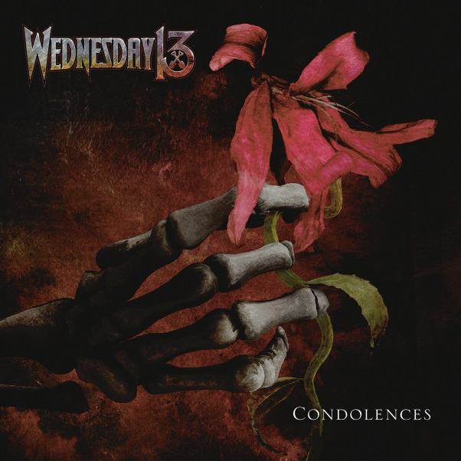

WEDNESDAY 13
»Condolences«

OUT: June 2nd, 2017

Line up: | WEDNESDAY 13 online:
Wednesday 13 | vocals  Roman Surman| guitar  Jack Tankersley | guitar  Troy Doebbler | bass  Kyle Castronovo | drums | www.officialwednesday13.com  www.facebook.com/officialwednesday13  www.nuclearblast.de/wednesday13
A grimly glamorous ghoul who first slithered from the cobwebbed shadows of Charlotte, North Carolina, in the early 90s, WEDNESDAY 13 has firmly established himself as the world's premier purveyor of balls-out horror punk insanity. With a vivid and vile imagination that has endeared him to countless fans of riff-driven macabre over the last two decades, he has been one of rock's most prolific protagonists, spreading his credo of grave-robbing rock 'n' roll and Hallowe'en debauchery around the globe and unleashing a seemingly endless stream of blood-spattered albums and EPs.

“All my favourite stuff, like KISS and ALICE COOPER and TWISTED SISTER, those guys set the bar pretty high,” he states. “I always wanted to do something in the worlds of those bands. That's the blueprint. It had to be as outrageous and crazy as that and I wanted to be on someone's wall one day and have their parents say 'Oh my god, what is that?' The formula's still there from when I started doing it as a kid and started wanting to be in a band. It's just GI Joe and Dracula!”

After several years of sharpening his creative teeth, WEDNESDAY 13 emerged from the fetid crypt of obscurity with his band FRANKENSTEIN DRAG QUEENS FROM PLANET 13, those masters of snotty schlock rock that released an astonishing five studio albums and six EPs between 1996 and 2002. Always the leader of the revolting pack, WEDNESDAY 13 then became a bona fide international rock star as front man for the MURDERDOLLS, his collaboration with SLIPKNOT’s Joey Jordison. The band took the world by storm, with Europe and the UK in particular succumbing to the feral charms of 2002 debut album, »Beyond The Valley Of The Murderdolls«; a raucous eruption of big tunes and bad attitude that noisily redefined the horror punk genre. After MURDERDOLLS went on an extended hiatus in 2004, WEDNESDAY 13 embarked on a widely lauded solo career that again provided him with an outlet for his relentless outpouring of fiendish musical and lyrical ideas. Albums like »Transylvania 90210« (released by Roadrunner in 2005), »Fang Bang« and »Skeletons« all cemented our pallid hero's reputation as the bastard son of ALICE COOPER and THE MISFITS, while his outlaw country project, BOURBON CROW and one-off glam metal vehicle, GUNFIRE 76 proved that he had sufficient versatility to survive outside the graveyard and abattoir.

MURDERDOLLS reconvened in 2010 for the vicious »Women And Children Last« album and another successful world tour before disappearing once more into the freezing midnight fog, leaving WEDNESDAY to revive his solo career with a few thousand volts of wicked electricity yet more highly praised albums and tours including 2014’s scintillating acoustic opus »Undead Unplugged« and the following year’s thunderous »Monsters Of The Universe: Come Out & Plague«. However, absolutely nothing that WEDNESDAY has created in the past has even touched upon the horrifying potency and allure of his brand new studio album, »Condolences«.

Frustrated with the arduous process of releasing his own music, our favourite black-hearted freak has thrown himself and his music into a whirling maelstrom of reinvention. The result is not just the heaviest and most authentically disturbing record of the great man’s career but also a huge creative leap forward, neatly encapsulated by the new album’s simple and direct title.

“It’s more of a serious WEDNESDAY 13 record, I guess,” he says. “The campiness has gone and it’s taken a darker vibe. It’s definitely not in the camp, sleazy world anymore. The band is visually stronger and that’s taken things to a new level. Normally my album titles are parodies of something, like »Women And Children Last«, that’s a VAN HALEN album title gone wrong! (laughs) So I wanted to make sure that this record came across as a brand new version of WEDNESDAY 13.”

In musical terms, »Condolences« showcases WEDNESDAY’s growing obsession with the world of heavy metal and its endless possibilities for exploring tales of horror and violence. Produced by renowned studio guru Zeuss, new songs like anthemic first single 'What The Night Brings' and the pile-driving 'Blood Sick' still exhibit a dash of B-movie weirdness and are full of WEDNESDAY’s trademark twisted lyrics, but where previous albums were rooted in the worlds of punk rock and glam metal, »Condolences« is a full-on modern metal record with gigantic balls and the attitude to match. From the glowering menace of 'Good Riddance' to the grandiose hellishness of the album’s 7-minute title track, it’s living, breathing, murdering proof that the WEDNESDAY 13 of 2017 means business. And business is mean.

“The punk rock vibe has left the building and it’s become a full-on metal vibe,” WEDNESDAY agrees. “I’ve been the horror-punk guy for years, but this is horror metal. It’s just evolution. Over the last ten years I’ve become a metalhead for the most part. That second MURDERDOLLS record just amped the whole thing up, and the guys in the band have influenced me with so much other stuff. It’s not just me with my SEX PISTOLS, ALICE COOPER and RAMONES records anymore! (laughs) Now I’ve got my band incorporating everything from death metal to rock’n’roll. It’s all across the boards. There are no rules. We can do whatever we want, whatever fits.”

Manifestly the strongest, heaviest and most individual album of his lengthy career, »Condolences« promises to push WEDNESDAY 13 into heavy music’s upper echelons once again. With determined plans to tour relentlessly in support of the new record, the future is looking dark, dangerous, exhilarating and wildly, unapologetically theatrical.

“It’s non-stop touring once the record comes out,” WEDNESDAY concludes. “We just did our first video for 'What The Night Brings' and the visuals are really cool. I’ve incorporated a lot of stuff I’ve been doing live, like this devil character I’ve been transforming into at shows, and that got worked in. We’re taking the music, the imagery and the entire stage show up a level. It’s gonna be a full-on theatrical stage production, so I’ll be busy as fuck on stage! I’ve been doing this shit for so many years, I started thinking ‘How can I make this fun again?’ (laughs)”

