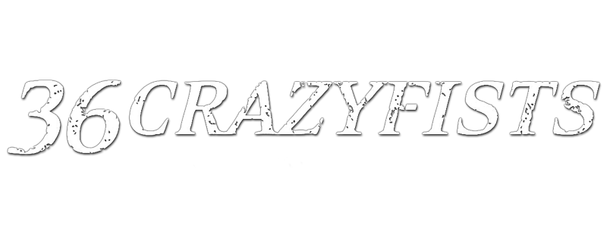Brock Lindow – Vocals
Steve Holt – Guitars
Mick Whitney – Bass
Kyle Baltus – Drums

Like a once frozen phoenix blazing through ten miles of suffocating ice, 36 Crazyfists arises in triumph. They are in the throes of career resurgence, a type of rebirth that can only be conceived in the fieriest of trials. This is one of the most important bands of the New Wave Of American Metal, keepers of a flame that might otherwise be extinguished. And they charge into 2015 holding that torch proudly aloft.

Time And Trauma arrives with all of the thunder one should expect from a band celebrating their 20th anniversary, emboldened by new management, a brand new label home with Spinefarm Records and the most aggressively focused, incessantly personal and relentlessly urgent full-length album of their double decade existence.

“This album represents exactly who we are, what we sound like, and what we’ve worked so hard to create over all of these years,” says vocalist and cofounder Brock Lindow. “We’ve never wanted to be run-of-the-mill, or to run with the pack. It’s important for us to have our own identity. This album certainly gets back to that.”

Band cofounder Steve Holt concurs. “Overall the idea was to write a rock record with no preconceived notions; just good riffs and good songs,” the guitarist says. “I wanted rock-oriented songs that would let Brock’s vocal melodies take the lead.”

36CF’s latest banger sees the vocal and guitar duo welcoming new drummer Kyle Baltus into the fold and reuniting with a familiar face, bassist Mick Whitney. “Kyle is an amazing young drummer. Mick and I had remained best buddies after he left the band. I frequently played him stuff I was writing and badgered him to rejoin the band,” Holt explains. “Finally the time was right for him and he said, ‘I’m in.’”

The band’s signature sound deeply connects with those enamored with Metallica’s Black Album, Soundgarden’s dark groove, Testament’s melodic thrash, the opaque atmosphere of Deftones and the raw authenticity of Alice In Chains. Lindow’s vibrato soaked howl conjures the brightest of the grunge era, all backed with true grit and creative dexterity. The guitars throttle brightly and loud, with head nod inducing clarity, and the rhythm section expertly lays it down with class and skill.

The album’s title track slow boils with a chugging groove that would make Crowbar blush, as Lindow lays it down line by line. “Lightless” recalls a bit of the vibe of Boston based “band’s band” Only Living Witness, with extremely emotional texture. “Vanish (We All Disappear)” opens the album with stark, immediate rawness. “Marrow” goes all the way back to 2011, evoking the atmospheric heft of Katatonia.

36 Crazyfists videos for songs like “Bloodwork,” “At The End Of August,” “We Gave It Hell” and “The All Night Lights” have amassed over 5 million views on YouTube. They’ve toured with Alice In Chains, Killswitch Engage and Atreyu. They built an international fanbase who has yearned for their return. They were among the first bands chosen to for the Rockstar Mayhem tour’s maiden voyage. Yet for nearly five years, 36 Crazyfists went underground, hibernating in quiet, away from prying eyes.

“Life just took its way with us,” explains Lindow. “We came off the road from the last record and my mom was diagnosed with cancer. I decided to take a year off to be with my mom. I went to chemo with her pretty much every day the whole year, as she got sicker. My grandmother actually passed away a month before my mom.”

As Lindow prepared to lose a parent, he became a parent. His daughter was 2 when his mom died. To say that it was a heavy time in the singer’s life would be an understatement. Not long after, his best friend’s wife was killed in an auto accident.

“If I didn’t have my daughter, boy, it could have been a lot worse. I had to be a parent. I had to be focused. The most important thing for me was to be someone she can be proud of, rather than some depressed drunk all of the time. You can really get pulled into some dark spots if you don’t keep putting one foot in front of the other.”

With the future somewhat uncertain for 36 Crazyfists, Holt continued writing anyway, for a new album that may or may not materialize and for separate projects. “I was writing classic rock type stuff with a buddy under the name CokeWulf and experimenting with acoustic stuff. All of it was so fun that I think some of it made its way into what I was writing for 36CF – the rock feel, the leads, the structure.”

Holt gave his longtime frontman and creative partner the necessary space to deal with his massive personal tribulations, keeping the flame burning brightly in the background for whenever it would be time for 36CF to reemerge. “I continued sending Brock the music I was writing during his mother’s illness and after her passing; I think the circumstances are reflected in the moodier stuff I was creating.”

36 Crazyfist’s return was tracked entirely at Holt’s home studio, lending it a cohesion and intimacy that may have been harder to achieve elsewhere. It’s a small place, which means the record boasts minimal editing, mostly full takes, real drums, real cabinets and vocals that were tracked in a living room. “It’s unpolished and I like it that way,” the guitarist declares. “It resembles the rawness we have live. It also captures the rawness of the material Brock was writing his lyrics about.”

Lindow describes performing the new songs as something of a “nightly therapy.” A few of the songs confront the loss of his mother head-on, including “11/24/11” (named for the date she passed away), as well as songs that are more sort of peripherally related. “Also Am I” is about the importance of some sort of faith, a type of prayer, in the singer’s life, regardless of whether he ascribes it to a particular organized religion (he doesn’t) or Holy Book (nope). The title track is about the trauma, loss and pain everyone must face and about hoping to outlive all of it.

But as much as the record addresses the fragility of life, the band is quick to point out that Time And Trauma is by no means doom and gloom. “The album isn’t dwelling on death,” Lindow points out. “It’s about trying to understand, but also, about elevating over the sad times and searching for a light in all of it. Time does heal. We have to keep going. The alternative is to check out, which I will not do.”

The band’s name was inspired by the 1977 Shaolin revenge tale directed by martial arts legend Jackie Chan, The 36 Crazy Fists (but uniquely stylized as 36 Crazyfists). The self-released In The Skin (1997) turned heads and Bitterness The Star (2002) introduced 36 Crazyfists to the world at large. A Snow Capped Romance (2004) and Rest Inside The Flames (2006) were their highest charting albums in the UK. The Tide And Its Takers (2008) and Collisions And Castaways (2010) both charted on Billboard’s Top 200, with Collisions hitting #3 on Billboard’s Heatseekers chart.

The Alaskan band’s Spinefarm debut is the strongest entry in an already impressive body of work comprised of nearly a half dozen albums. The group has worked with Roadrunner Records (Slipknot, Nickelback), mid-2000s tastemaker Ferret Music (Every Time I Die, In Flames) and the once promising rock upstart DRT Entertainment. Spinefarm puts them back many of the people who poured their passion into the band before, including ex-staffers from Roadrunner and Ferret.

Time And Trauma deals with the most important subject matter of the band’s storied history, while offering the most focused and purely 36 Crazyfists anthems they’ve ever released. Passing the 20-year mark, they’re as enthusiastic as ever about traveling, about performing, and about connecting with as many people as possible.

“We want to swing for the fences all over again,” the singer says, very cognizant of the feeling of rebirth that surrounds his band. “Who knows how many chances we’ll have to go all out like this? Oddly enough, even after 20 years of being a band, we’re still eager to prove ourselves. It’s a great thing, to always have a challenge to beat.”

