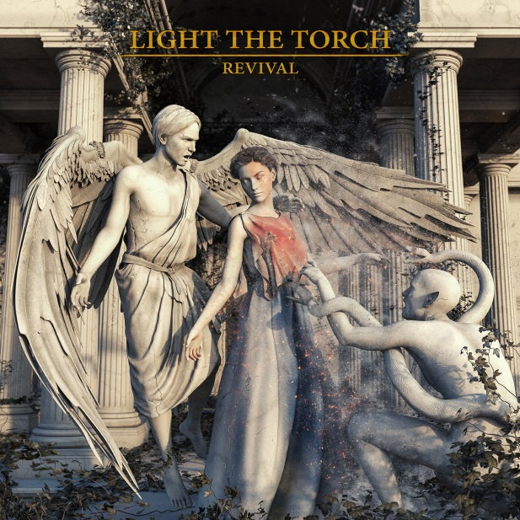

LIGHT THE TORCH

»Revival«

OUT: March 30th, 2018

Line up: | LIGHT THE TORCH online:
Howard Jones | Vocals  Francesco Artusato | Guitars  Ryan Wombacher | Bass  Mike Sciulara | Drums | facebook.com/LightTheTorchOfficial  twitter.com/LTTorchBand  instagram.com/lightthetorchband
The winds of change most definitely fanned the flame for LIGHT THE TORCH. On their 2018 full-length debut »Revival« [Nuclear Blast], the Los Angeles, CA trio—Howard Jones [vocals], Francesco Artusato [guitar], and Ryan Wombacher [bass]—drew from five years together as DEVIL YOU KNOW only to forge a wholly distinct path. Amidst myriad struggles, they returned from the brink under a new banner.

“2016 was a really tough year for us as a band, both personally and professionally,” admits Howard. “While going through some lineup changes we were also battling some issues with the use of our band name. At the same time, I was trying to deal with the loss of my oldest brother which really hit me hard. During that time, we just bonded like never before. We all meshed because we faced war together. We survived. At the end, we realized we were a real band and decided to make an album representing that resilience. Honestly, we came out of the dark. The name literally signifies what we went through.”

The musicians quietly struck the match for LIGHT THE TORCH during 2017. Without so much as telling either the label or management, they wrote the 12 anthems comprising »Revival« and recorded them in Los Angeles with the help of WOVENWAR and AS I LAY DYING bassist and producer Josh Gilbert [BULLET FOR MY VALENTINE, SUICIDE SILENCE] behind the board. Joined by EXTINCTION A.D. drummer Mike “Scuzz” Sciulara behind the kit, the guys put their heads down and really focused on making an album as a whole, placing more emphasis on the songs flowing cohesively from one to the next.

“It was time for a change,” the frontman continues. “It was time for us to try and stretch our wings. We were really going for songs. The structuring made more sense. I was focused on melody and harmony. I really cut loose. All in all, it was the perfect storm. We had so much fun making this, because there were really no restrictions other than creating a heavy and catchy body of work.”

The boys introduce the record with the first single and opener ‘Die Alone’. Powered by airtight riffing and a hummable lead, the verses immediately engage before the vocalist croons the anthemic refrain: “There’s nothing in the shadows, and you will be the one to die alone.”

“It was one of the first demos Fran showed me,” he recalls. “I listened to it while cruising around the UK on tour. It just worked. Lyrically, that song was like a letter to myself that I had jotted down from all of the stuff I’d been through.”

Elsewhere, ‘Calm Before The Storm’ builds from a thick guitar groove into an expansive chant. “It’s about trying to be there for those who need you,” Howard explains. “Everybody knows someone who needs a hand getting through tough times. While some may be beyond help, you never know when you can be the hand that makes a difference.”

Whether on the robust balladry of ‘The Great Divide’ or the pensive vulnerability of ‘The Safety of Disbelief’, melody takes center stage, driving one anthem after another.

“I write sappy songs,” he laughs. “There was enough that we had gone through that I had a whole wealth of emotions and stories. Some are fiction. Some are non-fiction. Some may apply to me. Some may not. If you listen closely, I promise you can hear where we’ve been and where we’re going.”

As far as “where they’ve been” goes, LIGHT THE TORCH maintains one of the most esteemed pedigrees in modern heavy music. From Howard’s decade at the helm of GRAMMY® Award-nominated and gold-selling titans KILLSWITCH ENGAGE and Francesco’s much-lauded stint in ALL SHALL PERISH and status as a shred virtuoso to Ryan’s tenure in BLEEDING THROUGH, there’s no shortage of experience. Still, »Revival« marks an important moment for all three men.

“It was a long road to get here,” reveals the singer. “We reworked everything. Once we started this, things snowballed. It was like, ‘Wow, we can breathe again.’ »Revival« felt like the appropriate name.”

Ultimately, LIGHT THE TORCH ignites the future for not only its members but metal at large.

“Everyone’s got a path,” Howard leaves off. “There will always be strange and unexpected twists and turns. More important than the struggle is how you handle it and come out of it. I don’t know what sparked it, but for us it translated into the music. This album is what we were supposed to make.”

