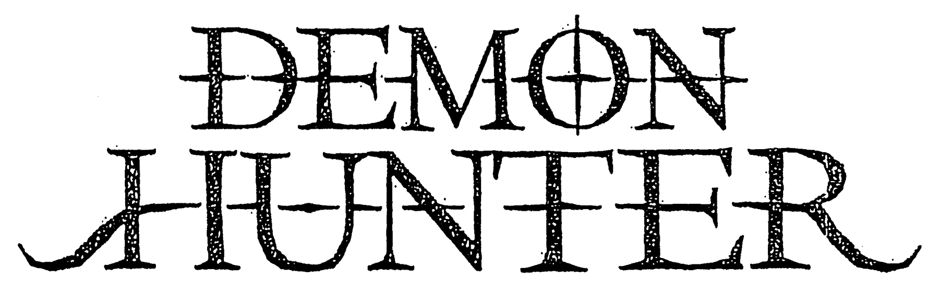

Ryan Clark – Vocals
Patrick Judge – Lead Guitar
Jeremiah Scott – Rhythm Guitar
Jonathan Dunn – Bass Guitar
Timothy “Yogi” Watts – Drums, Percussion

Demon Hunter is an American metal institution. The band embraces brazenly transcendent melodies, without apology, while maintaining a defiant heaviness reminiscent of the most timeless of metal music. For over a decade, Demon Hunter has weathered the changing tides of rock subculture, proving ever resistant to trends, and ever resilient, making music as determined and resolute as the men within the band.

Demon Hunter’s dedicated supporters and allies around the world wear the group’s symbol, lyrics and album imagery on their shirts, denim vests, backpacks, and uniforms, and in many cases, on their skin. The band has engaged their fans in direct, authentic and personal terms for years, since long before such efforts were seen as “strategy.”

The group’s extended family around the world cherish the band’s songs as personal anthems, instruments of empowerment, using them to mark chapters in their lives both good and bad, in celebration and in mourning, from weddings to funerals. Songs like “I Am a Stone,” “Not Ready to Die,” “Carry Me Down,” “Collapsing,” “LifeWar,” and “Fading Away” continue to resonate with fans, even as each successive album elicits ever more fervor from the band’s fierce, loyal supporters.

Even in the wake of the band’s greatest career triumph, the group’s members faced their greatest personal challenges. In the handful of years since Extremist enjoyed the band’s largest first week sales debut (at #16 on the Billboard 200 with roughly 18,000 sold) and produced the SiriusXM radio hit “The Last One Alive” and the somber “I Will Fail You,” Demon Hunter survived through nearly crippling adversity.

But their personal hardship and private struggle resulted in a renewed strength, embodied in sound and spirit on their eighth album, Outlive.

“In many ways, it feels like the five of us have done more living in these last couple of years than in the entire decade prior,” observes frontman, primary songwriter and founding member Ryan Clark. “Four of us became first time fathers and entering that amazing yet stressful phase of life together has brought us even closer, he adds.” Between the insanity of parenthood and a variety of other more difficult scenarios, all as the world-at-large seemingly crumbles around us, there was certainly no shortage of content to explore on this album.”

Outlive tracks like “Cold Winter Sun,” “Died in My Sleep” and “Half As Dead” are among the latest melodic metal mission statements in an arsenal rich with sonic diversity, melodic depth, and authentic passion.

As a headlining act, Demon Hunter helped introduce audiences to bands like August Burns Red. They’ve co-headlined with Red and toured as direct support for both In Flames and As I Lay Dying in the United States and parts of Canada. They’ve traveled to South America, Europe, and Australia, headlining major festivals and club shows alike.

Ryan and his brother, former guitarist Don Clark, created Demon Hunter after the turn of the millennium, unleashing a self-titled first album backed by a still shadowy and enigmatic lineup in 2002, assembling a touring lineup that introduced Jonathan Dunn as bassist.

Summer of Darkness broke through in the metal, hardcore and Christian rock scenes in 2004, with MTV2 rotation for “Not Ready to Die” and a spot on the “Resident Evil: Apocalypse” soundtrack helping push it to 100,000 in sales. Watts was a fulltime member by the time they released The Triptych, which sold close to 150,000 copies in the U.S.; 2007’s Storm The Gates Of Hell crossed the 100,000 mark as well.

Judge toured on that record as lead guitarist, officially joining in 2009 with Live in Nashville. The World Is A Thorn debuted with first week sales of 14,000, as “Collapsing” became their highest charting song at metal and specialty radio. True Defiance, cemented the current lineup with Scott’s addition in 2012, breaking into Billboard’s Top 40. In the wake of Extremist, Demon Hunter has sold roughly 600,000 records.

Like Extremist, Outlive was produced/engineered by the band’s own Jeremiah Scott (Living Sacrifice, The Showdown) and mixed by Zeuss (Rob Zombie, Queensrÿche, Hatebreed), with additional input from longtime collaborator Aaron Sprinkle (Anberlin, New Found Glory). The record was made primarily in Nashville, home to Scott, Judge, and Watts, with additional recording in Seattle, home to Clark and Dunn.
Demon Hunter’s musical identity is forged from diverse elements that coalesce into a singular electric charge, merging seemingly disparate sound with seamless agility: the energy of America’s thrash metal legends; the catchiness of Europe’s melodic death metal innovators; the gloomy atmospheric majesty of gothic rock; the song craft of dark romantic pop; and the fist-pumping aggression of Southern groove.

Demon Hunter’s body of work is born from unwavering commitment, uncompromising creative determination, and stark recognition of the reality of an often-cold world tempered in defiant hope. It’s made up of smartly constructed, confessional lyrics; heady and catchy melody; monster riffs; bottom heavy grooves; the collision of meticulous production and urgent raw power; bold imagery and bolder themes.

